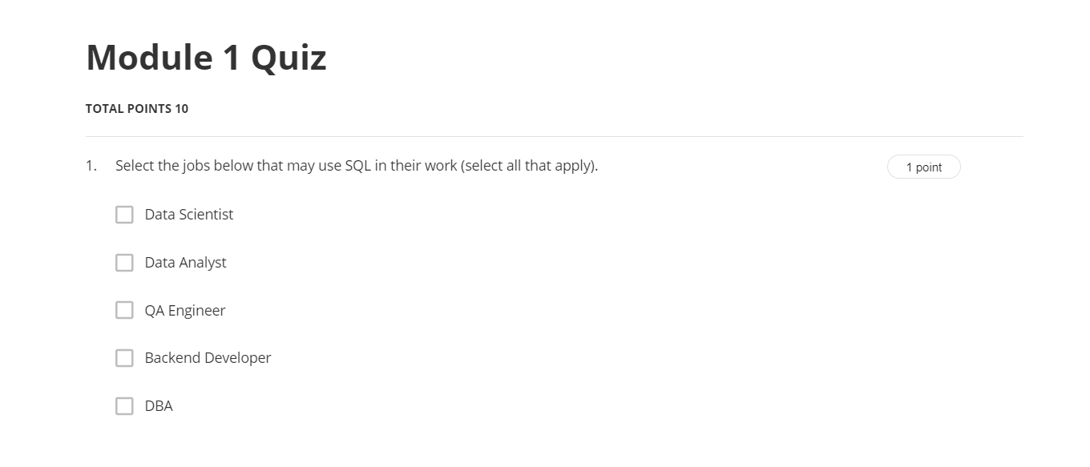

Ans:-Data Scientist

Data Analyst

QA Engineer

Backend Developer

DBA

-----------------------------------------------------------------------------------------------------------------------------------------------------------------------------------------------------------------------------------------------------------------------

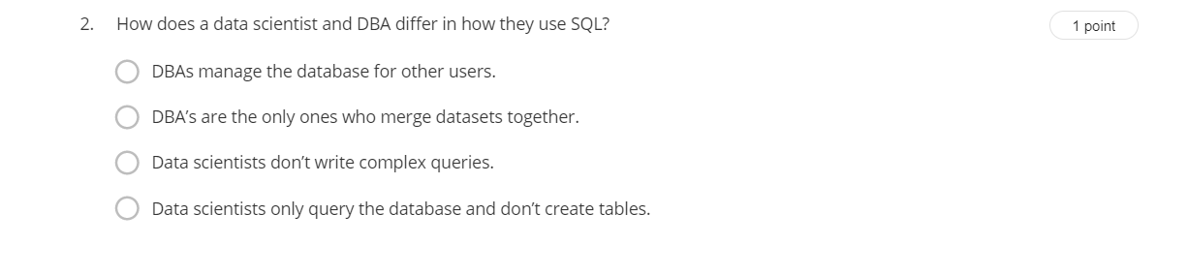

Ans:-DBAs manage the database for other users.

------------------------------------------------------------------------------------------------------------------------------------------------------------------------------------------------------------------------------------------------------------------------------

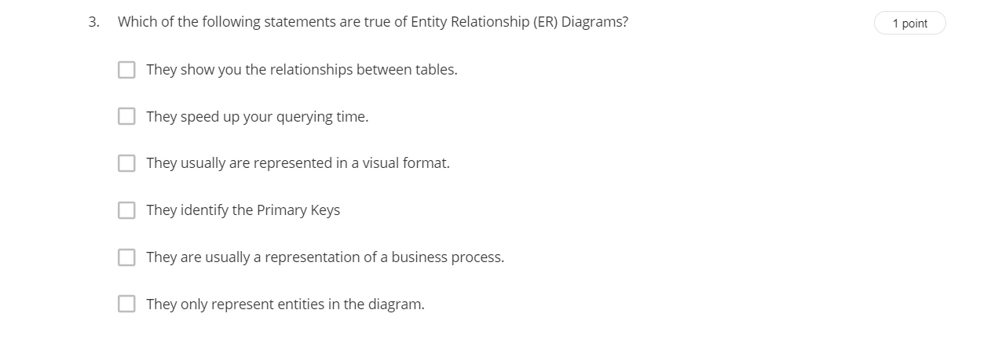

Ans:-

They show you the relationships between tables.

They usually are represented in a visual format.

They identify the Primary Keys

They are usually a representation of a business process.

------------------------------------------------------------------------------------------------------------------------------------------------------------------------------------------------------------------------------------------------------------------------------

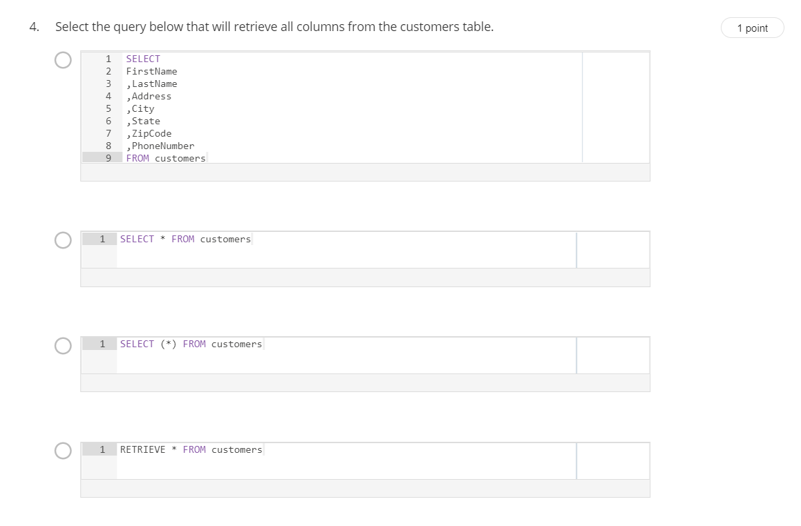

Ans- SELECT \* FROM customers;

------------------------------------------------------------------------------------------------------------------------------------------------------------------------------------------------------------------------------------------------------------------------------

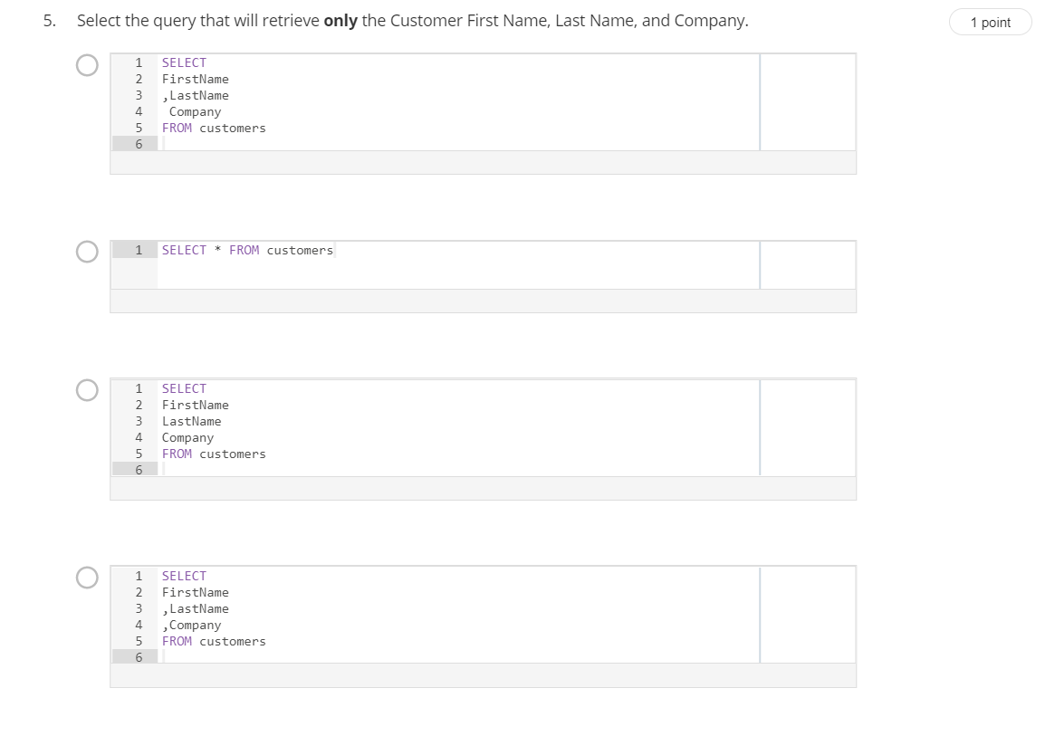

Ans:-

SELECT

FirstName

,LastName

,Company

FROM customers

------------------------------------------------------------------------------------------------------------------------------------------------------------------------------------------------------------------------------------------------------------------------------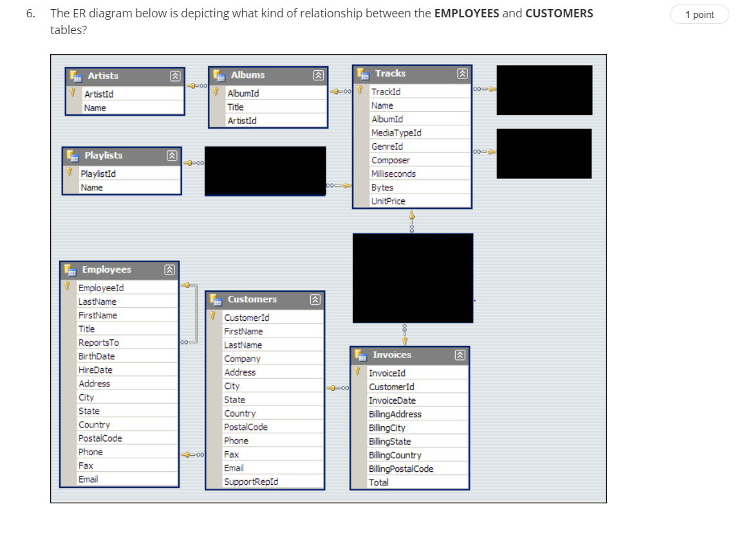

Ans:-One-to-many

--------------------------------------------------------------------------------------------------------------------------------------------------------------------------------------------------------------------------------------------------------------------------------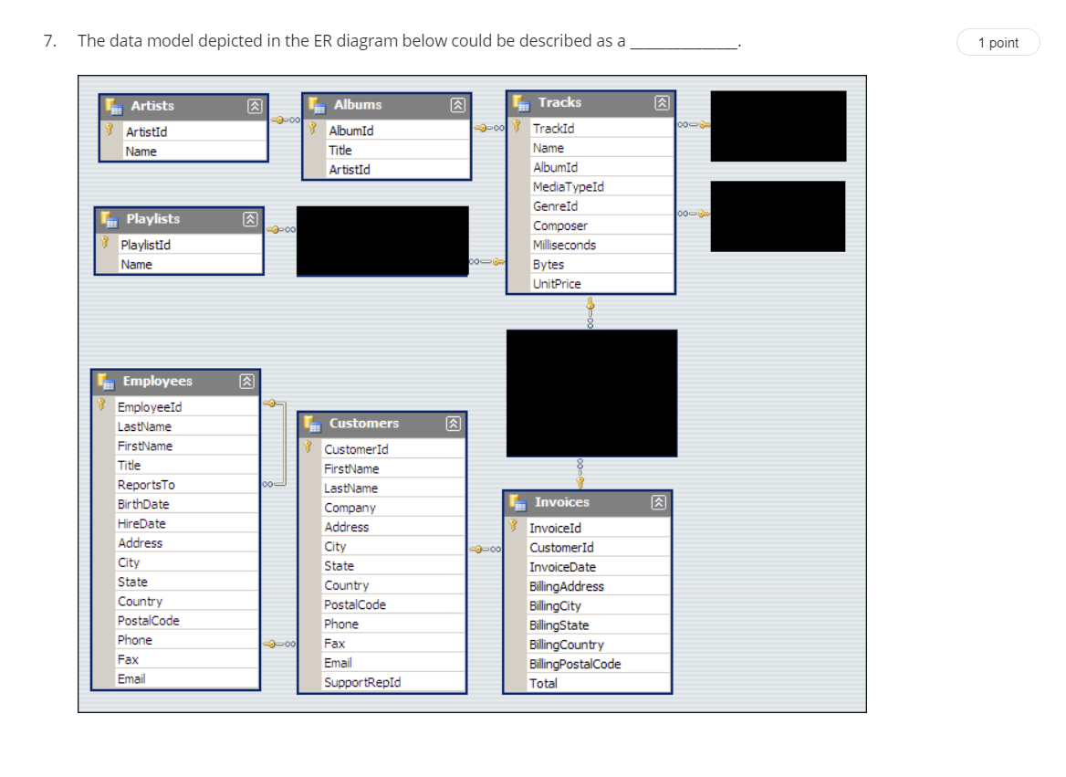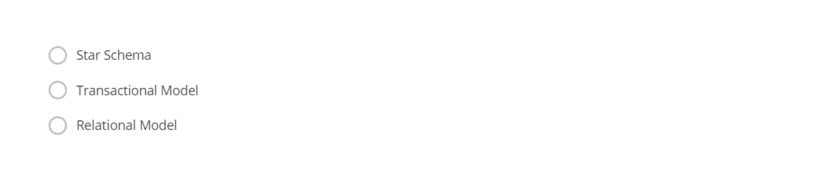

Ans:-Relational Model

------------------------------------------------------------------------------------------------------------------------------------------------------------------------------------------------------------------------------------------------------------------------------

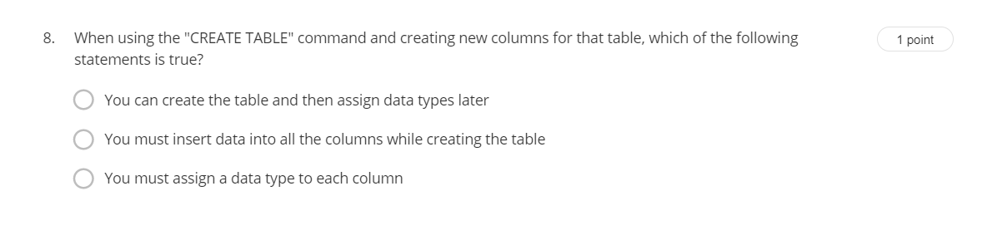

Ans:-you must assign a data to each column

------------------------------------------------------------------------------------------------------------------------------------------------------------------------------------------------------------------------------------------------------------------------------

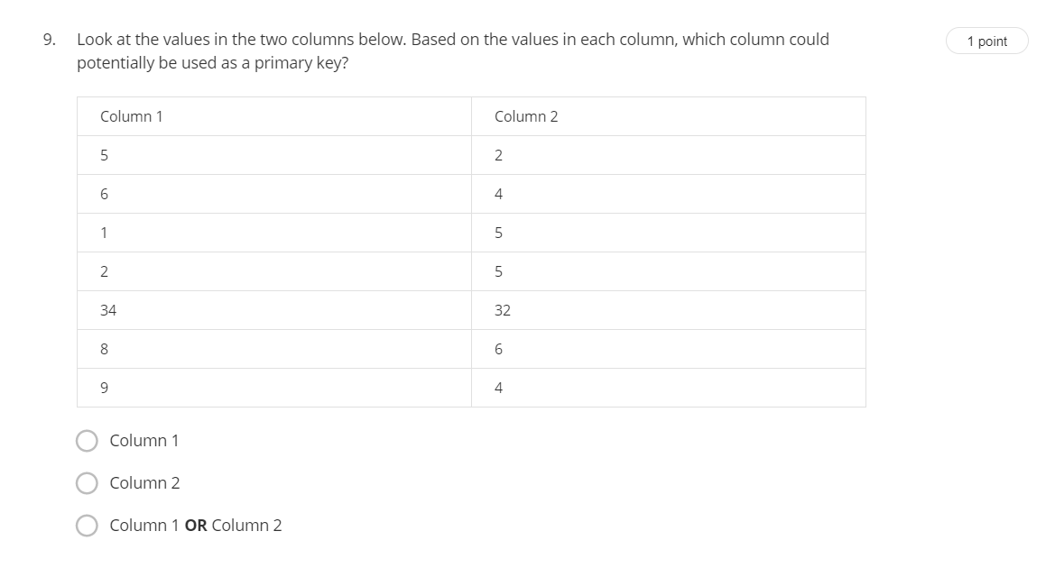

Ans:-column1

------------------------------------------------------------------------------------------------------------------------------------------------------------------------------------------------------------------------------------------------------------------------------

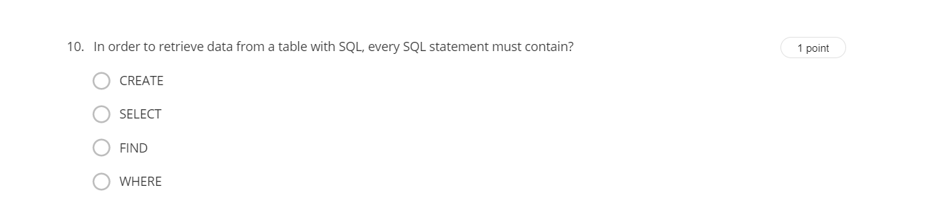

Ans:-Select